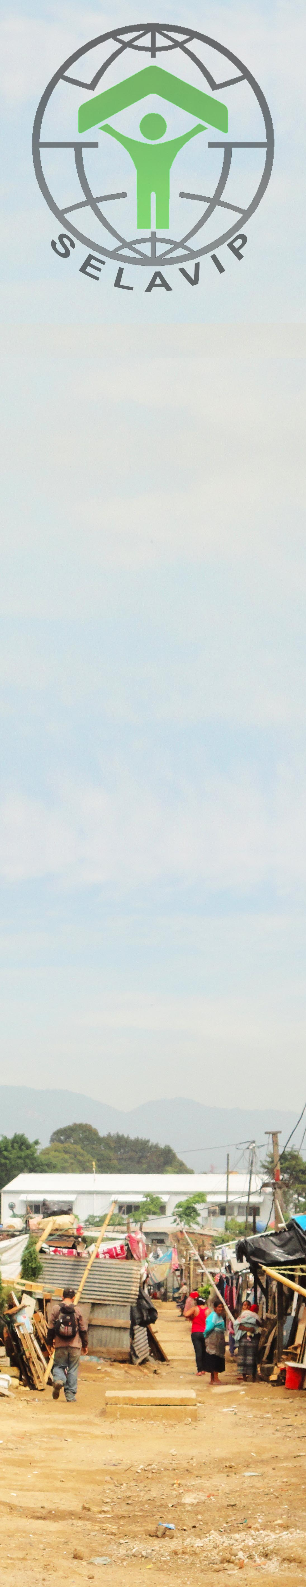
CALL FOR 2012-2013 PROJECTS

SELAVIP is a private foundation that supports housing projects for very poor urban families. Our focus is on “extreme social emergency”, that is, people who dwell in very precarious and unsafe conditions and places, or are forced to occupy urban land, exposed to evictions. Other families have no other alternative but to live as “unwelcome guests” in the homes of relatives and neighbors, in crowded conditions and lacking minimal privacy. Under such harsh conditions, they cannot even dream of meeting the requirements of conventional housing programs, in spite of their efforts to do so. SELAVIP wants to open realistic alternatives to these poor urban families who do not “fit” into any existing housing programs, public or private. We want to invite new groups and communities of the developing world to join so many other partners who are working for decades to shelter the urban poor. By funding small innovative projects, SELAVIP helps them to acquire experience and be able to move on to bigger projects in the future. Our call is open to a wide range of proposals that address acute housing problems in the cities of developing countries.

Areas of interest
Projects can deal with different aspects of the complex reality of homelessness in developing regions, from housing production or improvement, to promotion of community based processes to secure shelter. A plan to build or improve shelter should also include activities to start or strengthen “community-driven” urban and housing processes. Innovative and realistic strategies should make possible for the poorest families to access housing. The cost of each unit should not exceed USD 1000 for a new house and USD 600 for an improvement. Other proposals that are more "process oriented" should help to empower or organize communities, but also lead to clear and measurable results in terms of housing and/or urban services. Priority will be given to initiatives that help the poor access land and basic shelter rather than to those seeking to improve shelter that has already reached some physical or legal consolidation. Projects that can be scaled up by other entities in the future, or impact local and national policies, are also a priority for SELAVIP.

Maximum amount granted per project: US$ 65.000.

We invite groups working in developing countries to send innovative projects by mail during July and not after August 19. You can visit www.selavip.org or contact selavip@vtr.net if you have any questions or require more information. Maximum size of attachments is 2 Mb, so if you plan to include photos or drawings please reduce their size and/or send in separate messages.
Selection process
SELAVIP will carefully select those projects that meet the criteria mentioned above, and present them at the Board meeting in November. The final list of projects to be funded during 2013 will be published on our website. The proposals we receive usually exceed those we can finance, so many good projects sometimes cannot be included in that list. SELAVIP would like to encourage their proponents to persevere looking for other sources or to apply again next year.

REMEMBER:
- Maximum amount: USD$ 65.000 per project.
- Basic and affordable shelter for vulnerable urban households: no more than USD$ 1.000 for a new house and USD$ 600 to improve existing shelter.
- Projects should be completed by September 2013.
- We do not finance operational costs of projects.
- Matching funds from public/private/ community/ international sources are welcome to increase the impact of the project; these funds should be clearly mentioned in the application.
- Application form attached; additional information can be annexed.
- All costs/expenditures only in USD.
- Only projects submitted by e-mail before August 19 will be included in the selection process.

2012-2013 PROJECT PRESENTATION


1. BASIC INFORMATION
Country/region :
Project title :
Organization in charge :
Person in charge of project :
e-mail /phone/fax :
Funds needed (SELAVIP) :USD$
Cofinancement (describe sources) :USD$
Total cost of project :USD$
Nº of families who will participate :
Cost per housing unit (if applicable) :USD$

2. BACKGROUND INFORMATION
Briefly explain housing problems to be addressed and their context. Also describe how this project relates to other areas or activities of the institution that will implement the project, and to other important issues in the housing and/or social sector in your country. Mention how the project focuses on the main concern of SELAVIP, as stated before, mainly that of providing basic shelter to the poorest of poor urban families. Also mention how you plan to combine the funds provided by SELAVIP with other funds or resources to make the project sustainable.

3. OBJECTIVES AND BRIEF DESCRIPTION OF THE PROJECT
Describe main goals and activities planned to achieve them. Propose a schedule of activities in time and include an estimate of costs per item and other sources of financement that will also contribute to the project. Remember to express all costs in US$. Also describe experiencie, technical staff and basic facilities of the organization in charge of implementing the project. Be specific about the way technical assistance will be provided, and how the community and/or families will be participating in this project. Mention the impact that this project could have at a local or national level.

4. EVENTUAL PROBLEMS
Briefly describe problems or situations that should be solved in order to implement the project, and how you plan to deal with them.

5. ADDITIONAL INFORMATION
Legal status of proponent, organization and staff, infrastructure, main financial sources, briefly describe experience in the field of housing and urban projects. During the selection process, SELAVIP may require additional/more detailed information during the selection process. DO NOT INCLUDE BANK INFORMATION aat this stage.

If you have any questions about the application, please contact us: selavip@vtr.net selavip@selavip.org . website www.selavip.org

Joan Mac Donald
Erika Carmona
Juan I. Miquel

SELAVIP
June 2012

