After the successful evictions of Gypsies in Italy, and buoyed by the success of the politicians in Rome, Brent Council today decided that they would try their hand at clearing a few of their unwanted Traveller’s from the site that lives in the shadow of Wembley Arena.
As local land becomes more and more valuable with every day that the 2012 Olympics gets closer, Brent Council is looking to clear as many of their Traveller site residents as possible, and today their enthusiasm for the task got the better of them.
Having been given the go ahead yesterday afternoon to evict two families from the Brent site, when the High Court over turned the eviction order yesterday evening they didn’t stop the bailiffs from proceeding with the eviction as planned.
At just before 09:30 I was sitting in a caravan taking tea as the bailiffs swooped on the site. Flying into the site came a phalanx of vehicles and bailiffs intent on evicting a couple of young families, whose crime was not having anywhere else to go. Although they have lived on site most of their lives, Brent Council has refused them a licence.
The bailiffs seemed to be mostly bully boys from Poland or Eastern Europe, and as people tried to tell them that they had no right to invade the site with a view to evicting anyone, they sat in their vehicles smiling and pretending to not understand English, saying “You speak my boss”.
The local site residents flooded out from their homes indignant that an illegal eviction should be attempted on their site and made their feelings plain.
Eventually as the bailiffs retreated from the site and the Council Liaison Officer confirmed that they had no right to be there. The bailiffs drove off leaving with the words that “Next time there will be more of us”.
When questioned about the attempted illegal eviction, a Brent Council senior lawyer called Clive Romain said “I didn’t get told the eviction had been cancelled until 09:30 this morning”.
Solicitors for the site residents Davis Gore Lomax said in reply “Brent Council were served with the Judicial Review papers yesterday afternoon at 16:31 and so they knew there was a chance the eviction would be halted by the High Court”
He went on to say “Last night when the decision came through from the High Court, I called and told the night staff immediately, I emailed them and this morning I telephone Brent Council again at 08:10”.
The precursor to this foray was a letter sent out by Clive Romain, reminding everyone on the site that if they tried to prevent any of the up and coming evictions they would be subject to arrest without warrant.
Is Brent council really so uncaring about Human Rights or is it that they have caught a whiff of the anti Gypsyism that has been flowing out of Italy without any kind of real protest from the UK government, and seen an opportunity to grab a little land back from the Traveller’s?
This week the European Union held its first ever Roma Summit, attended by countries from all over Europe (even the Italian government sent a representative) some 450 people were there.
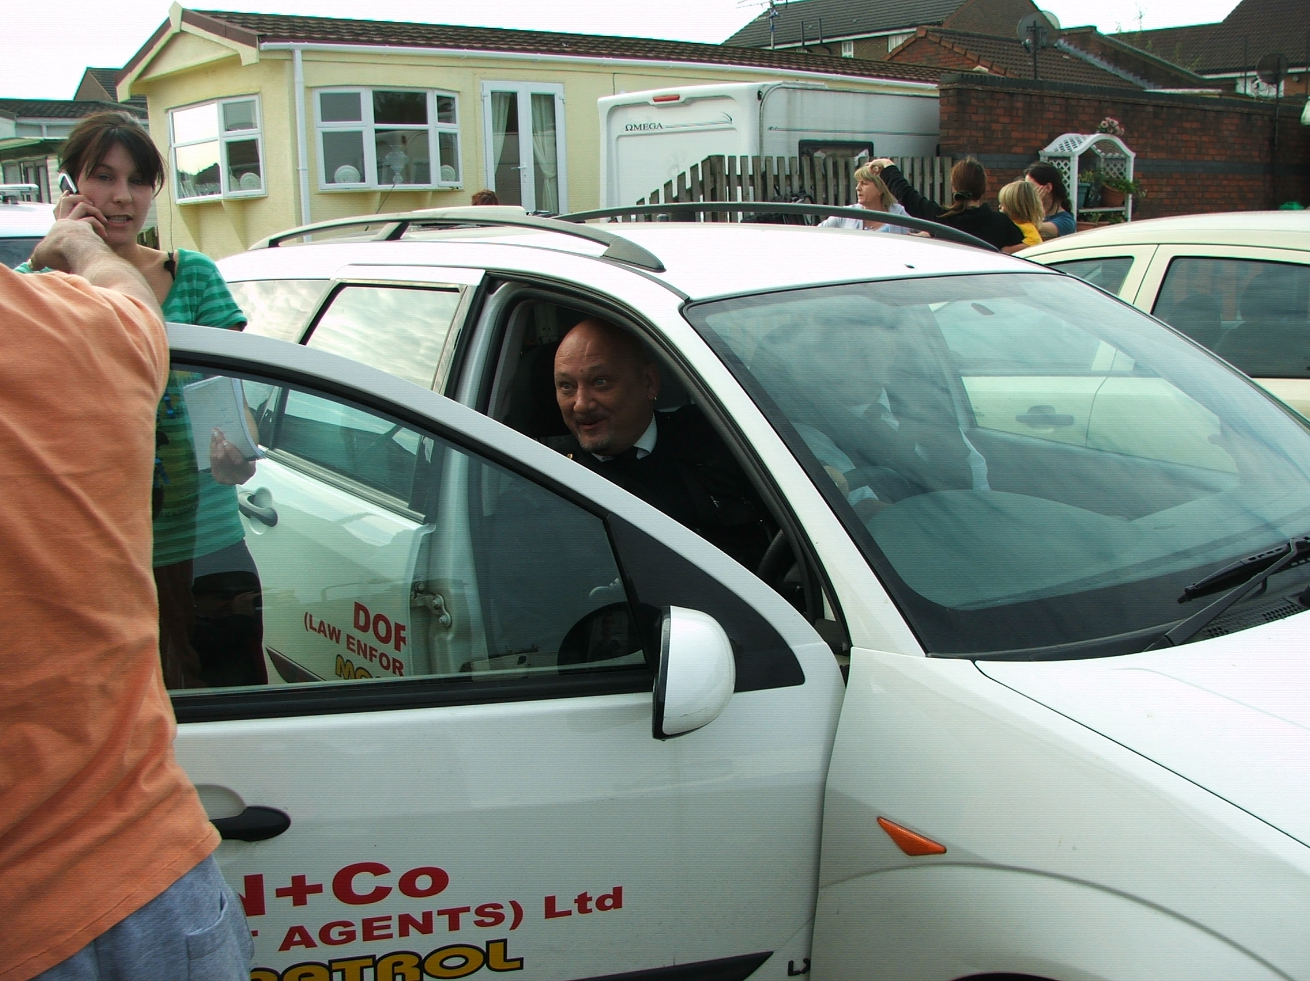
One of the delegates asked me why isn’t there anyone here from the UK government? Why hasn’t the UK signed up for the Decade of Roma inclusion?
I couldn’t answer.
As I try to sum up this mornings work by Brent Council representatives and employees all I can think of is the chant from the demonstration held by the Brent Traveller’s last week “We are Human, We are Human”. Perhaps Brent Council should remember that.
Joseph G. Jones (07756 917937)
The Gypsy Council Ltd
Photograph by Joseph G. Jones
Brent Site , Cheerful Bailiffs Attempting an Illegal Eviction. 19th September 2008

