THE CITY AND THE SOCIAL HOUSING
Burghs, settlements, occupied houses, tenancy, guesthouse

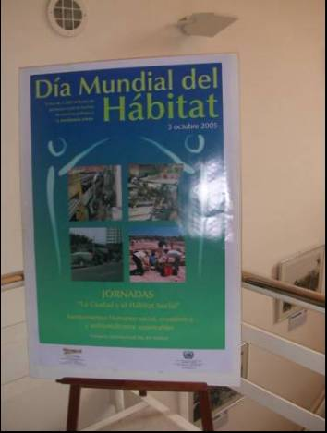
Monday 3 October 2005, h 9:30 - 15.00 at the UN’s Informational Centre (C.I.N.U.) in the Autonomous City of BUENOS AIRES, Republic of Argentina, the Ceibo T.B.- Trabajo Barrial, organized a workshop: “The City and the Social Housing” with the support of national and international organizations of the civil society, the legislature of the city and local and national governments.

The objectives of the day have been to:

* stimulate the generation of integrated social, house and urban policies.
* spread and reflect about medium-and long-term strategies in order to reduce the housing deficit.
* strengthen participative spaces for helping to overcome marginalism
* contribute to the construction of worthy and adequate habitats for the population.
* Create an ambit of interchange for planning actions and elaborating a national outline housing law.
* Think about actions and convocations for the next year (2006).

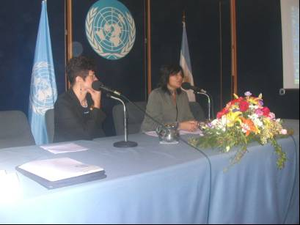
As well, and thanks to the statements, the meeting will try to incorporate new forms of organization in order to reduce the housing deficit in our Country, the relation between Social Organizations and Government in the administration of the housing policies, as well as the “right to housing” as an essential human right, and the joint and several and cooperative basis; the articulation of the public-private-NGO’s-International organizations, and to promote the implementation of agile programmes in which people can get an answer, in a short-term period, for a worthy housing.

At the meeting, several subjects have been participating: representatives of international organizations, local and national governmental officials, no governmental organizations from different areas of the Country, the local legislature, delegates of the parliamentary housing committee as well as delegates from different provinces and municipalities of the Country.

The International Alliance of Inhabitants contributed at the day through a letter of adhesion that has been sent by its coordinator, Cesare Ottolini, and thanks to the presentation speech by Cristina Reynals "Redes Internacionales por un Hábitat Digno" (International Networks for a Dignified Housing).

At the end of the day, “Padre Pichi” was honoured for his commitment for the Social Housing.

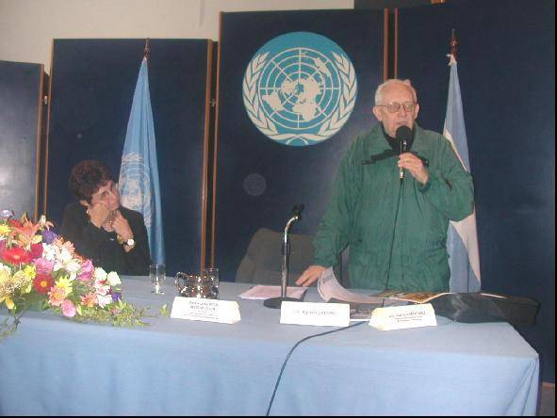

Source: Press Release - EL CEIBO-01.10.05 - 15 5162 5774

