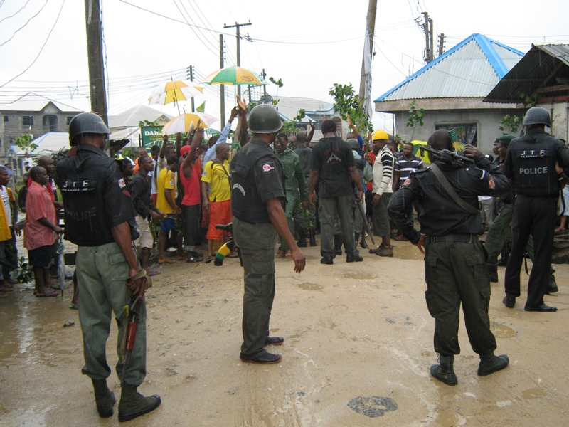
ANNEXURE A1
Photo 1: Invasion of the waterfronts by the Joint Military Task Force (JTF)

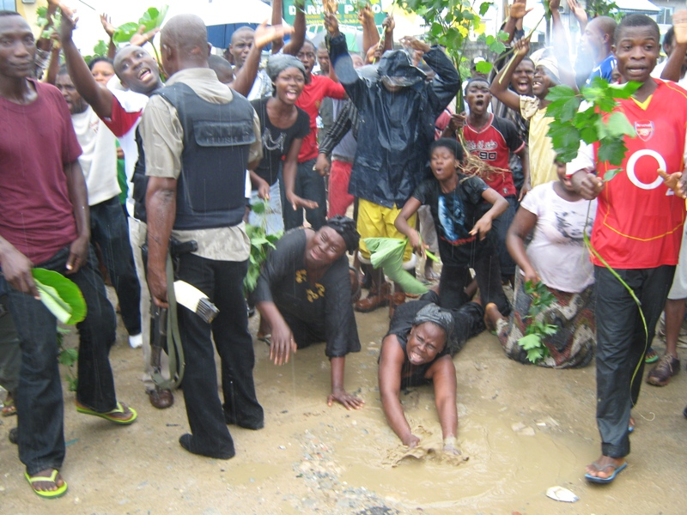
ANNEXURE A2

Photo 2: The waterfront widows begging government not to demolish their houses


ANNEXURE B
Photo 3: Refusal by Government to spare the waterfronts led to protest
ANNEXURE D

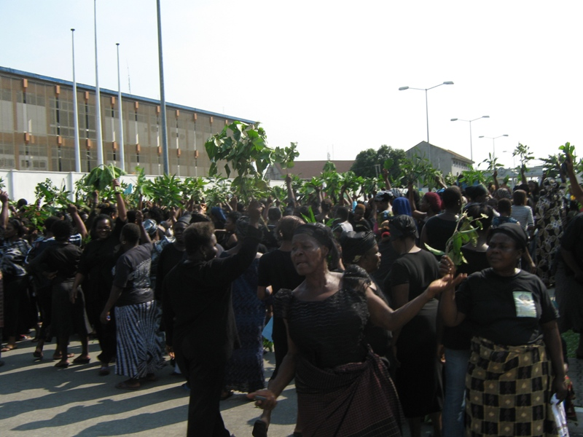
ANNEXURE C1
Photo 4: Thousands of aggrieved residents joined the protest the following day

Photo 4: Thousands of aggrieved residents joined the protest the following day

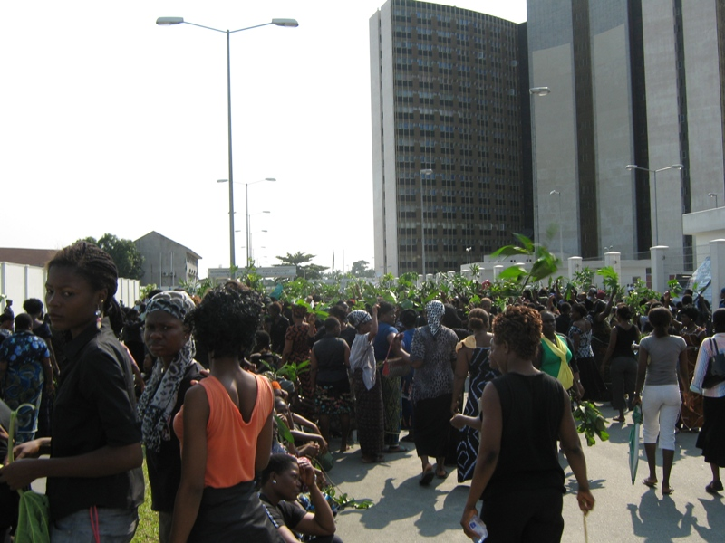
ANNEXURE C2
Photo 5: The aggrieved residents matched to Government House with green leaves

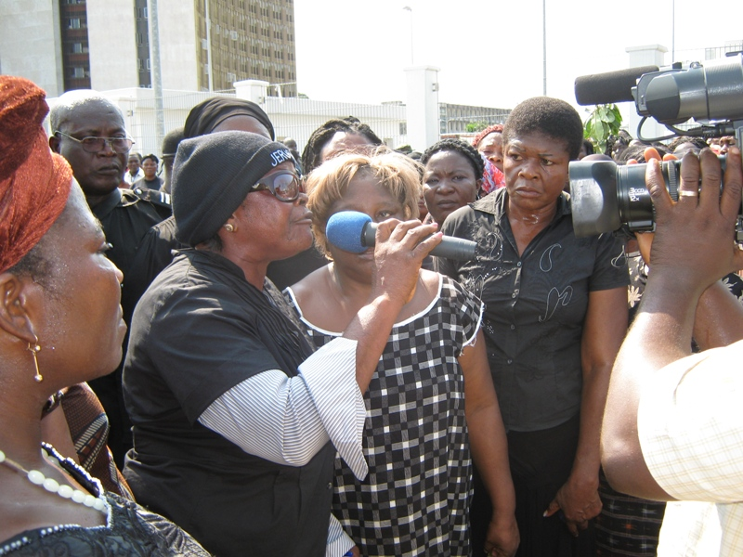
ANNEXURE C3
Photo 5: The Waterfronts Women Leader Addressing the Press during the Protest

